**KWAME NKRUMAH UNIVERSITY OF SCIENCE AND TECHNOLOGY, KUMASI**

**COLLEGE OF ENGINEERING**

**DEPARTMENT OF GEOMATIC ENGINEERING**



**PROJECT TOPIC**

**RESEARCH THESIS ON MAPPING INFORMAL SETTLEMENTS USING REMOTE SENSING: A CASE STUDY OF GREATER KUMASI**

**NAMES:** **BOAMAH JEFFERSON (8174619)**

**COURAGE KUMAWU (8176919)**

**SUPERVISORS: DR.YAW MENSAH ASARE**

**MR. ELISHA AKANLO ANANKANSA**

**YEAR: AUGUST, 2023**

# DECLARATION

We hereby declare that this thesis is a product of my own and to the best of my knowledge, it contains my original work and no previous material publication by another person, except for instances where due references and acknowledgment has been given in the text. The content of this work has not been submitted to any other University or tertiary institution for an award of any degree, diploma, or certificate in either Ghana or abroad. I have also acknowledged any assistance that has contributed to the success of this thesis.

Boamah Jefferson (8174619) ……………... ………………  
(Student Name & ID) Signature Date

Courage Kumawu (8176919) ……………... ………………  
(Student Name & ID) Signature Date

Certified By:  
Dr. Yaw Mensah Asare .…..………… ………………  
Supervisor Signature Date

Certified By:  
Prof.Jonathan Quaye Ballard …….……... .....................  
Head of Department Signature Date

# DEDICATION

To our loving family, for their unwavering support and inspiration throughout our academic journey. This thesis is dedicated to all of you. Thank you for being our rock.

# ACKNOWLEDGEMENT

We thank God for His unflinching love and grace throughout this journey. To Him, God Almighty, be the glory!

I express my profound gratitude to Dr. Yaw Mensah Asare and Mr. Elisha Akanlo Anankansa for his patience and constructive feedback that shaped this thesis to its completion. We are grateful for his insights and guidance throughout this journey.

To our families, we are grateful for their prayers and support.

# ABSTRACT

This study thoroughly evaluates pixel-based and object-based image analysis techniques for the task of mapping and categorizing informal settlements utilizing Sentinel-2 imagery. The pixel-based methodology, considering each pixel as a distinct analysis unit, delivered promising results, with an accuracy of 93.25%, precision of 72.77%, recall of 62.98%, and an F1 score of 67.52%. Nevertheless, challenges were observed in its application to intricate urban settings with mixed land uses due to misclassification tendencies. In contrast, the object-based approach, grouping connected pixels into singular units, showed superior performance metrics, boasting an accuracy of 95.70%, precision of 73.66%, recall of 81.34%, and an F1 score of 77.31%. Although segmentation difficulties arose when distinguishing smaller clusters of informal settlements from surrounding non-settlement areas, this technique proved more effective overall. The selection between these methods should be steered by factors such as computational resources, project timeline, and unique project requisites. This study's findings make notable contributions to the utilization of Sentinel-2 imagery in the classification of informal settlements, holding substantial relevance for the domains of remote sensing and urban planning.

# TABLE OF CONTENTS

DECLARATION ii

DEDICATION iii

ACKNOWLEDGEMENT iv

ABSTRACT v

TABLE OF CONTENTS vi

LIST OF TABLES x

LIST OF FIGURES xi

CHAPTER ONE 1

INTRODUCTION 1

1.1 Background of Study 1

1.2 Problem Statement 2

1.3 Research Objectives 3

1.4 Research Questions 3

1.5 Scope of Study 4

1.6 Justification of study 4

1.7 Organization of study 5

CHAPTER TWO 6

LITERATURE REVIEW 6

2.1 Introduction 6

2.2 Definition and Characteristics of informal settlements 6

2.3 Importance of mapping informal settlements 7

2.4 Challenges in mapping informal settlements 8

2.5 Existing approaches to mapping informal settlements 10

2.5.1 Participatory mapping techniques 10

2.8 Remote sensing data 17

2.8.1 Satellite imagery 17

2.8.1.1 Challenges in mapping informal settlements using satellite imagery 18

2.8.1.2 Importance of mapping informal settlements using satellite imagery 20

2.8.2.1 Importance of aerial imagery in the mapping of informal settlement 23

2.8.1.2 Challenges of mapping informal settlements using aerial images 24

2.9 Conceptual framework 26

CHAPTER THEE 28

METHODOLOGY 28

3.1 Introduction 28

3.2 Study Area Selection 28

3.3 Data Collection and Analysis Workflow 31

3.4 Data Acquisition 31

3.5 Data Preprocessing 32

3.6 Feature Extraction 33

3.7 Classification or Segmentation Techniques 34

3.8 Validation and Accuracy Assessment 35

CHAPTER FOUR 37

RESULTS AND DISCUSSION 37

4.1 Introduction 37

4.2 Pixel-based Image Analysis 37

4.3 Object-based Image Analysis 39

4.3 Test of Accuracy for Pixel-based Image Analysis and Object-based Map 40

4.3.1 Accuracy computations 41

4.3.1.1 Overall Accuracy and Kappa value 41

4.3.1.2 Pixel based Accuracy computations for informal settlements 42

4.3.1.3 Object-based computations for informal settlements 43

4.3.1.4 Accuracy 43

4.3.1.5 Precision 43

4.3.1.6 Recall 44

4.3.1.7 F1 Score 44

4.4 Discussion of findings 44

CHAPTER FIVE 46

CONCLUSION AND RECOMMENDATION 46

5.1 Conclusion 46

5.2 Recommendations 47

REFERENCE 48

# LIST OF TABLES

Table 3.1 confusion matrix for the pixel-based classification 40

Table 3.2 confusion matrix for the object-based classification 41

# LIST OF FIGURES

Figure 3.1 Map of Greater Kumasi (Source: Authors’ Construct) 29

Figure 3.2 flow chart of the study (Source: Author’s Construct,2023) 31

Figure.4.1 Pixel-based Analytical map of Greater Kumasi 37

Figure.4.2 Comparative Analysis of Informal and formal settlement from the pixel-base Map 38

Figure.4.3 Object-based Analytical map of Greater Kumasi 39

Figure.4.4 Comparative Analysis of Informal and formal settlement from the Object-based Map 40

# CHAPTER ONE

# INTRODUCTION

## 1.1 Background of Study

Informal settlements, as defined by the Global Security and Disaster Reduction Centre (GSDRC), are residential areas where residents frequently lack tenure security for the land or home, they live in. Typically, basic city infrastructure and services are lacking in the neighbourhoods. Housing is typically positioned in physically and environmentally dangerous regions, and it may violate current building and development rules (Amis, Preston and Turner, 2016). The political economy, poor planning, the encroachment of land tycoon and misguided planning philosophies are only a few of the causes of informal settlements. They emerge haphazardly in the absence of planning, and they are typically characterized by wasteful land use, degradation of the environment, poor living conditions, uncertain employment, and disagreement over land use. Their unbridled development can contribute to the chaotic spread of cities. More over half (61.7%) of the urban population in Africa resides in informal settlements. By 2050, the number of people living in metropolitan areas in Africa is projected to expand from a total of 400 million in 2010 to a staggering 1.2 billion, including substantial rises in both the number and population of informal settlements. Governments and academic institutions are concentrating on how to successfully integrate informal settlements into the sustainable development process (Zhang et al., 2020). Kibera, one of the largest slum settlements in the world, is located in Kenya and is home to more than 500,000 Kenyans, making it the largest in Africa (UN-Habitat, 2004).

In Ghana, slum communities are common, and an estimated 40% of the country's urban population lives there (Abass and Kucukmehmetoglu, 2021). Slum development in Ghanaian cities has sparked debate over environmentally responsible urban management and planning (Amoako & Cobbinah, 2011). Mapping informal settlements has been made possible via remote sensing, which has proven to be a very useful and efficient technology (Stark et al. 2019). Remote sensing can map the number of slums in high-risk areas as well as overall environmental conditions (Netzband and Rahman, 2009). There has been a considerable improvement and increase in the number of government-sponsored activities and services supplied to informal settlements since the digital mapping of these areas was updated in late 2009 (Hagen, 2017).

The proposed research aims to apply remote sensing techniques for mapping informal settlements in Greater Kumasi. By integrating different remote sensing datasets, such as low-medium-resolution satellite imagery and aerial photographs. The study seeks to identify and characterise informal settlements in the region. Additionally, the research will explore the relationships between the physical characteristics of informal settlements, such as building density, and land use patterns.

## 1.2 Problem Statement

The increasing urbanization of Ghana and the failure of successive metropolitan administrations to invest sufficiently in sustainable housing as well as infrastructure to satisfy the needs of the urban population are blamed for the creation of informal settlements (Adarkwa and Post 2001). The availability of unattractive, unoccupied land affects where slums are located in the Kumasi Metropolis. On these lands, poor families and city migrants dwell, eventually turning these areas into slums. Environmental issues, including river contamination and inadequate environmental sanitation, are linked to slum dwellers' activities (Takyi et al., 2021). Urban planners, policymakers, and government organisations face a huge challenge in effectively addressing the socio-economic problems linked to these settlements due to the absence of accurate and current information on informal settlements in Greater Kumasi (Agyabeng *et al.*, 2022)​. Traditional data gathering and mapping techniques are time-consuming, expensive, and frequently fall short of capturing the dynamic nature of informal settlements. Therefore, a novel strategy utilising remote sensing methods is required to precisely map and monitor informal settlements in Greater Kumasi. By investigating the potential of remote sensing as a tool for mapping and monitoring informal settlements, this project seeks to close this information gap by offering trustworthy data for the region's urban development planning and evidence-based decision-making.

## 1.3 Research Objectives

The aim of the research is to utilise remote sensing techniques and data to accurately map informal settlements in Greater Kumasi. The main objectives of this research are as follows:

1. To classify informal settlements using pixel-based image classification
2. To classify informal settlements using object-based image classification
3. To assess the best between object-based and pixel-based algorithms for informal settlement classification.

## 1.4 Research Questions

The following questions are presented as a guide for examining the study's aims.

1. How can we optimize pixel-based techniques for accurate informal settlement classification in satellite imagery?
2. How can object-based techniques be adapted for precise differentiation of informal settlements in satellite images?
3. How does the accuracy of object-based algorithms compare to pixel-based ones in classifying informal settlements?

## 1.5 Scope of Study

The research will be limited to Kumasi, Ghana. The study will map informal settlements using publicly available low-resolution data, such as Sentinel2 satellite images. Using low-resolution data, the study will compare various image classification algorithms based on pixel-based and object-based image analysis and determine the most effective image analysis approach for mapping informal settlements in Kumasi. It will assess the precision and dependability of the chosen algorithm approach for mapping informal settlements. Although this research focuses on Kumasi, the findings can be applied to any area exhibiting similar characteristics to Kumasi.

## 1.6 Justification of study

Urban growth in Kumasi is influenced by both spatial plans and impulsive informal development patterns (self-organization). Contrasted with spatially planned neighborhoods, self-organization is more common. To better address Kumasi's urban development concerns, more work needs to be done to comprehend informal growth patterns and how to incorporate them into the mainstream planning process (Korah et al., 2017). Many researches focus on mapping informal settlements using very high-resolution images in combination with machine-learning object-based image analyses (Fallatah, Jones, and Mitchell, 2020), (Gram-Hansen et al., 2019), (Assarkhaniki, Sabri and Rajabifard, 2021). The cost involved in acquiring these very high-resolution images is very high, especially when dealing with very large areas. This makes it non-prohibitive for non-governmental organizations and low-income countries like Ghana (Gram-Hansen et al., 2019). There is therefore a need to find the best alternative method for classifying informal settlements using publicly accessible low-resolution data like Sentinel and Landsat. Object-based image analysis (OBIA) methods are recommended by various researchers for identifying informal settlements, and as such, various researchers use an OBIA approach to map informal settlements (Fallatah et al., 2019). However, it is important to note that the best analysis for classifying informal settlements may depend on various factors, such as the type of data available, the size and complexity of the study area, and the specific research questions being addressed (Fallatah et al., 2019). Furthermore, there is still no conclusiveness when selecting an algorithm for mapping informal settlements. This research will contribute knowledge to the already available body of knowledge to help reduce some level of ambiguity in selecting the right algorithm for classifying informal settlements.

## 1.7 Organization of study

The research endeavour is segmented into five chapters, commencing with Chapter 1 presenting a comprehensive outlook on the topic. Chapter 2 proceeds to review relevant literature while Chapter 3 ascertains pre-processing, data collection methodologies, algorithm selection, and model training. Chapter 4 endeavours to deliberate on the scrutinized data, culminating in Chapter 5, which culminates with the research findings.

# CHAPTER TWO

# LITERATURE REVIEW

## 2.1 Introduction

The chapter provides a review of the theoretical framework and literature used to conduct this research. It begins by discussing informal settlement as a concept, defining it, and its characteristics. The chapter then goes on to discuss the importance, challenges, and existing approaches to mapping informal settlements. The chapter concludes by reviewing the role of remote sensing in informal settlements, including its benefits, limitations, and data analysis for informal settlement mapping.

## 2.2 Definition and Characteristics of informal settlements

According to the (UN-Habitat, 2015), people who reside in settlements that fit any of the following descriptions are considered to be living in an informal settlement; residents that lack tenure security over the land or homes they live in, with options ranging from squatting to substandard rental housing. Also, the city's infrastructure and essential services are typically absent from or inaccessible to these communities. Again, the house is frequently located in physically and environmentally risky places, and it might not adhere to contemporary planning and building rules. Rural-urban migration, sometimes known as "inserting," may result in the formation of informal settlements. This style of housing, which refers to construction that takes place on bare land, is primarily seen in peri-urban areas which refers to the edges of cities as observed by Dovey and King (2011). The autochthonous villages that are encircled by developed regions during the urbanization process are another sort of community that is viewed and considered as being informal. Counihan (2017) defines "Settling" as the creation of an unofficial hamlet on unrecorded and unbounded territory in the context of informal settlement.

## 2.3 Importance of mapping informal settlements

Finding and addressing the presence of informal settlements is a critical first step in planning and renovating impoverished regions, with the ultimate goal of achieving Sustainable Development Goals (SDGs) while ensuring that no one is left behind (Assarkhaniki, Sabri, and Rajabifard, 2021). These settlements, characterized by inadequate living conditions and often lacking in basic amenities, pose significant challenges to the well-being of their inhabitants. By way of illustration, Gram-Hansen et al. (2019) addressed how NGOs, such as the United Nations Children's Fund (UNICEF), rely on accurate maps that depict the locations of informal settlements, enabling them to provide targeted fiscal and social aid to those in need. The importance of monitoring informal settlements becomes apparent when considering the large number of people living in such areas and the high levels of risk and vulnerability they face, especially during disasters (Hofmann et al., 2008). Rumbach and Kim (2016) mention how these settlements are particularly susceptible to calamities due to poorly constructed housing and their limited integration into urban infrastructure. A study by Matarira, Mutanga, and Naidu (2022) reveal that mapping informal settlements offers several key benefits that extend beyond disaster preparedness and response. They also revealed that by involving the residents in the mapping process and granting them access to the resulting data, community participation and engagement in urban planning and development can be fostered. This empowerment enables residents to advocate for their rights and actively participate in decision-making processes that directly affect their lives. Moreover, mapping informal settlements provides valuable insights to urban planners and policymakers. Often, such settlements are not represented in official maps and statistics, making it challenging to devise targeted strategies for their development. By gaining a better understanding of the spatial distribution and attributes of these settlements, authorities can design more effective interventions to improve living conditions and infrastructure. The process of mapping informal settlements promotes collaboration and knowledge-sharing among various stakeholders, including researchers, policymakers, and practitioners (Graesser et al., 2012). The exchange of perspectives and expertise enables the development of comprehensive strategies that address the complex challenges associated with informal settlements more efficiently. In support of all the importance highlighted, finding and addressing informal settlements cannot be overstated when striving to achieve the SDGs and uplift impoverished regions. Mapping these settlements serves as a crucial tool for NGOs and organizations like UNICEF to provide targeted assistance to those in need. It also aids in disaster recovery efforts, enhances community participation in urban planning, and facilitates collaboration among stakeholders for more effective and sustainable solutions. By recognizing the significance of informal settlements and employing mapping techniques, we can take significant strides toward building inclusive and resilient communities that leave no one behind in the pursuit of sustainable development.

## 2.4 Challenges in mapping informal settlements

There are various problems mapping informal settlements. Each difficulty increases the difficulty of accurately capturing and portraying these towns on maps. One noteworthy example is that informal settlements frequently lack formal documents or land titles, making it difficult to establish correct borders or title information. According to Toulmin (2009), land titling isn't just complicated in numerous urban scenarios, but it also entails competing claims, such as politically powerful parties asserting possession within informal settlements where huge segments of the low-income people dwell. Accurately defining borders or determining who owns what can be challenging in informal settlements due to a lack of legal documents or land titles. A study by Wang, Xu, and Lin (2022) mentions the quick and dynamic changes informal settlements go through in terms of population expansion, construction structures, and land use. Maintaining accurate and up-to-date maps is difficult because of these changes. Additionally, statistics on informal settlements may be insufficient or erroneous, particularly in places with little capability or access to resources for data gathering. This can make it more difficult to produce accurate and thorough maps. Data-gathering attempts can be hindered by safety concerns. Bempah et al*.* (2021) refers to how difficult it is for mapping teams to acquire information on the ground since some informal settlements are situated in places with poor access or security issues. In terms of construction types, materials, and designs, informal settlements show tremendous variability. It takes serious thought and thorough field research to accurately depict this diversity on maps. Previous studies on evaluating informal settlements as observed by Ansari, Malhotra, and Buddhiraju (2020) comment on the variations in data formats, sizes, and quality, combining data from diverse sources, such as remote sensing, satellite images, and ground surveys, can be difficult. Accurate mapping depends on achieving data interoperability. Wang, Xu, and Lin (2022) again reveal that resources such as human, financial, and technical resources are needed for mapping informal settlements. The absence of sufficient resources and capacity can impede mapping attempts in environments with limited resources. For the mapping of informal settlements to be successful, it is crucial to engage with local stakeholders and people. Building trust, ensuring community involvement, and addressing issues are important yet difficult to accomplish.

## 2.5 Existing approaches to mapping informal settlements

### 2.5.1 Participatory mapping techniques

Participatory mapping, as defined by Mwanundu and Fara (2009), is the process of producing maps by local communities, usually with the aid of supporting institutions like governments (at various levels), non-governmental organizations (NGOs), universities, and other actors involved in land-related planning and development. Citizens are requested to mark preferences, places, and other elements pertaining to a certain topic on a map as part of this exercise. Participatory mapping approaches include the following:

1. **Mental mapping**: Refers to the approach of asking participants to draw a map of their community purely from memory. It is a cost-effective and resource-efficient method that aids in the identification of important features and landmarks in the community.
2. **Ground mapping:** Involves physically exploring the community and carefully mapping out significant features and landmarks. This technique provides a more thorough and precise representation compared to mental mapping, but it necessitates more time and resources.
3. **Participatory sketch mapping:**It entails collaborating with a group of participants to construct a community map using paper and pencils. It is a low-cost and resource-efficient technique that assists in identifying key features and landmarks in the community.
4. **Transect mapping:** It entails traversing the community along a predetermined route and carefully mapping out noteworthy features and landmarks. This technique offers a more detailed and accurate representation than ground mapping, but it requires additional time and resources.
5. **Participatory 3-dimensional modeling:** Involves constructing a physical model of the community using materials like clay or cardboard. It is a high-cost and resource-intensive technique that enables the creation of a detailed and accurate representation of the community.

**2.5.2 Geospatial technologies for mapping informal settlements**

To map and keep an eye on informal settlements, geospatial technologies like remote sensing and satellite imaging have been extensively deployed. These methods offer useful information on the size, density, and spatial distribution of settlements. They enhance urban planning and policymaking by allowing the detection of impromptu structures, road networks, and changes through time (Ramirez-Lovering, Spasojevic and Prescott, 2020; Tjia and Coetzee, 2022). Drones, or unmanned aerial vehicles, provide a flexible and affordable method for mapping informal communities. UAV-captured high-resolution imagery can give precise details about the morphology of settlements, different kinds of buildings, and infrastructure. UAVs can access remote locations and collect current data for monitoring and analysis (Ramirez-Lovering, Spasojevic and Prescott, 2020). Geographic Information Systems (GIS), a different geospatial technology, are essential for integrating and interpreting spatial data about informal settlements. GIS may offer a thorough picture of informal settlements' characteristics, including population distribution, service provision, and vulnerability assessment by merging remote sensing data, socio-economic data, and infrastructure information. Data collection in the field is made possible by mobile data collection technologies like cell phones and tablets. With the help of these technologies, data collection for mapping informal settlements may be done more accurately and efficiently while also collecting spatial data, conducting surveys, and capturing photographs. Mobile data-gathering platforms make it easier to retrieve data and enable real-time data changes (Tjia and Coetzee, 2022). These methods offer insightful information about informal settlements, facilitating the development of policies and decision-making based on facts. Policymakers and scholars can gain a better understanding of the geographical dynamics, socioeconomic conditions, and infrastructural requirements of informal settlements by utilizing geospatial technologies.

**2.6 Overview of remote sensing**

Remote sensing is the art and science of collecting information about the Earth's surface without physically touching it (Lillesand, Kiefer and Chipman, 2014). This is accomplished by using different types of sensors mounted on satellites or aircraft to capture images and data from a distance. These sensors come in different types such as optical, thermal, and radar sensors. Images are captured by optical sensors in the visible, near-infrared, and shortwave infrared regions of the electromagnetic spectrum. Thermal sensors measure the temperature of the Earth's surface, whereas radar sensors detect the shape and structure of the surface using radio waves. Image processing, data fusion, and machine learning can all be used to analyse remote sensing data. Image processing entails improving and analysing images to gather useful data. Data fusion is the process of combining data from multiple sensors to create a more complete picture of the Earth's surface. Algorithms based on machine learning can be used to classify and analyze data automatically (Chi et al., 2016). However, Sun et al (2022) point out that because of the complexity and variability of the Earth's surface, as well as the limitations of the sensors and algorithms used to collect and process the data, interpreting remote sensing data can be difficult. To address these issues, researchers are developing new methods and techniques for remote sensing data analysis, such as semantic graph-based methods that can assist in the integration and interpretation of large data sets. Remote sensing has numerous applications in various fields. Remote sensing, for example, can be used in agriculture to monitor crop health, estimate crop yields, and detect pests and diseases. Remote sensing can be used in forestry to map forest cover, monitor deforestation, and estimate biomass. Remote sensing can be used in urban planning to map land use, monitor urban growth, and assess the environmental impact of urbanization.

**2.7 Role of remote sensing in mapping informal settlements**

The first step in improving the most vulnerable populations is to locate informal settlements in urban areas, which is something that remote sensing has been utilized to do over the past few decades (Weir, McQuillan and Francis, 2019; Fallatah, Jones and Mitchell, 2020).

**2.7.1 Advantages of remote sensing in mapping informal settlements**

With remote sensing, enormous areas may be covered and whole countries' worth of informal settlements can be seen in detail. A macro-level understanding of the issue is possible thanks to the ability of satellite images to acquire specific information about the amount and distribution of settlements. Regular imagery acquisition using remote sensing systems, like satellites and airborne sensors, enables rapid updates on the expansion and transformation of informal settlements. This makes it possible to monitor and evaluate how dynamic these settlements are, aiding planning and policy initiatives (Ansari, Malhotra and Buddhiraju, 2020). Numerous field surveys are frequently used in traditional methods of mapping informal settlements, which can be time-consuming, resource-intensive, and expensive. By utilizing satellite or aerial data, remote sensing offers a more affordable alternative and eliminates the need for extensive ground-based data collection. Using remote sensing data enables standardized and reproducible analysis, assuring uniformity and comparability between various geographic areas and periods. This makes it easier to spot trends, patterns, and changes in informal settlements, allowing for useful benchmarking and comparisons. It also offers a method for mapping informal settlements that is impartial and objective. By identifying and defining settlements based on predetermined indicators and characteristics, automated image analysis approaches like object-based image analysis (OBIA) can be used to reduce subjectivity in the study (Fallatah et al*.*, 2018). The spatial extent, building types, road systems, and surrounding ecosystems of informal settlements can all be captured using remote sensing data. This multidimensional data can help targeted interventions and policy decisions by assisting in understanding the physical characteristics, growth trends, and socioeconomic dynamics of informal settlements (Ansari, Malhotra and Buddhiraju, 2020). Urban planning, infrastructure development, and catastrophe risk reduction can all benefit from mapping informal settlements using remote sensing. To improve the living circumstances and resilience of informal settlements enable the identification of areas in need of improvement, promote the allocation of resources, and supports evidence-based decision-making (Fallatah et al*.*, 2018).

**2.7.2 limitations of remote sensing in mapping informal settlements**

When data on informal settlements is published, it is typically insufficient and is rarely available. This is due, in part, to the costly and challenging nature of collecting massive amounts of data (Gram-Hansen et al*.*, 2019). Very High Resolution (VHR) and High Resolution (HR) satellite imagery have been used in nearly all of the current efforts to locate and map informal settlements. The fact that VHR/HR is an extremely expensive source of data and might not be available owing to budget/funding constraints, especially in developing nations, is one of its limitations. Results obtained by far misclassify formal regions as informal, notwithstanding the high cost and high accuracy of VHR/HR's detection of informal settlements. Since satellite images and other types of remote sensing data frequently have a low spatial resolution, it can be difficult to precisely map the small-scale characteristics and details found in informal settlements. To identify specific structures or differentiate between various forms of informal settlements, the resolution might not be sufficient. It's possible that remote sensing data doesn't give an accurate and current picture of informal settlements. In informal settlements, new buildings are continually being erected, while older ones are being renovated or destroyed. A study by Assarkhaniki, Sabri, and Rajabifard (2021) reviews that it can be expensive and difficult to get frequent and timely updates on remote sensing data. The context of informal settlements may not be sufficiently shown by remote sensing data alone. Often, further fieldwork or ground-truthing is needed to confirm and complete the remote sensing data. This may entail gathering information on infrastructure, the socioeconomic environment, and the distinctive features of informal settlements. Informal settlements are frequently found in intricate urban landscapes with a variety of overlapping structures and mixed land uses. In these heavily populated locations, it may be difficult for remote sensing tools to precisely define borders and detect certain features. Remote sensing analysis can be complicated by shadows, occlusions, and the varied nature of informal settlements (Acolin and Kim, 2021). Hofmann, Taubenböck, and Werthmann (2015) describe how access to high-quality remote sensing data may be difficult, particularly in developing nations with a high prevalence of informal settlements. It may be challenging to find accurate and current imagery for mapping informal settlements in some places due to inconsistent coverage or a lack of accessible data sources.

**2.7.3 Remote sensing data analysis for informal settlements mapping**

There have been several attempts to identify informal settlements using remote sensing technologies and data, such as active sensors and satellite images (Du, Zhang and Zhang, 2015; Wurm et al., 2017). These settlements play a crucial role in urban growth management, policy execution, and the pursuit of sustainable development goals, making their mapping and evaluation essential (Assarkhaniki, Sabri and Rajabifard, 2021; Matarira, Mutanga and Naidu, 2022).

Texture analysis has emerged as a commonly used approach to monitor morphological changes in informal settlements. Various methods, including the grey level co-occurrence matrix (GLCM), contourlets, curvelets, lacunarity, local binary patterns (LBPs), and line support regions (LSRs), have been investigated. Additionally, object-based image analysis and texture analysis have been combined with machine learning to improve accuracy. However, due to the diverse morphologies of informal settlements and challenges associated with remote sensing data, a consensus on the best mapping strategy is currently lacking. Factors such as feature sets, data gaps, sensor characteristics, and scale issues impact the accuracy of mapping. Recent research by Matarira, Mutanga, and Naidu (2022) focuses on integrating collective knowledge to gain a deeper understanding of texture-based classification for mapping informal settlements, aiming to address these difficulties. Systematic reviews and research have been conducted to identify variables influencing texture analysis, such as sensors, geographic areas, algorithms, and accuracy assessment techniques. Again, the use of open data in conjunction with remote sensing photography has been explored to identify the structure and patterns of informal settlements. This strategy not only aids in locating and assessing these settlements but also aligns with the inclusive sustainable development goals (SDGs), contributing to the resolution of challenges posed by rapid urbanization and population expansion in developing nations (Assarkhaniki, Sabri, and Rajabifard, 2021). For accurate classification, the incorporation of multimodal data and spatial-temporal fusion models is essential as noted by Fan, R. et al (2022)*.* They went further to review a promising approach that involves the use of multimodality data, such as time-series human activity data and very-high-resolution (VHR) remote sensing images. Urban informal settlements can be effectively classified by employing a hybrid Transformer-based spatial-temporal fusion network that combines deep learning models with spatiotemporal fusing layers. The outcomes of this approach have been encouraging, resulting in improved kappa values and overall accuracy when compared to previous models (Fan, R. et al., 2022).

## 2.8 Remote sensing data

The term ‘Remote sensing data’ was defined by Colgalton as data gathered from a range using sensors mounted on satellites or aircraft. This data can include a wide range of information about the Earth's surface, such as land use, vegetation, water bodies, and urban zones (Congalton, 2015). To capture data and deep insight from remote sensing data, a variety of techniques, including image processing, spatial analysis, and machine learning, can be used. The imagery from remote sensing can be used to identify and clearly define the boundaries of informal settlements, and to analyse their spatial pattern and shifts in time, as in the discourse of mapping informal settlements. Applying remote sensing data for mapping informal settlements has numerous advantages over traditional survey-based methods, such as the capacity to yield detailed, accurate, and up-to-date data at a relatively low cost (Lillesand, Kiefer and Chipman, 2014; Matarira, Mutanga and Naidu, 2022). Some examples of remote sensing data are satellite imagery and aerial imagery.

### 2.8.1 Satellite imagery

Satellite imagery is the collection of visual or non-visual data from Earth observation satellites orbiting the Earth. These orbiting satellites come with sensors and cameras that can detect various wavelengths of light, including visible, infrared, and microwave. The satellite imagery obtained provides extensive data about the Earth's surface, including land cover, vegetation, bodies of water, and habitation patterns. Since 2020, the SkySat constellation, for example, has provided multispectral images with a 0.5 m resolution that can be used to estimate NDVI(Pinto et al*.*, 2023). Different types of satellite imagery exist in this modern era, and they come in different resolutions. Some types of satellite imagery are Landsat, PlanetScope, Sentinel, Digital Globe and many more.

1. **Landsat:** For many years, agricultural and socioeconomic applications have exploited Landsat satellite imagery. It is excellent for tracking changes in land use and land cover over time and has a spatial resolution of 30 meters.
2. **Sentinel:** Sentinel is a class of satellite imagery with a spatial resolution of 10 meters and is ideal for tracking changes in water quality and quantity as well as in land use and land cover.
3. **PlanetScope:** With a spatial resolution of 3 meters, PlanetScope satellite imagery is valuable for tracking changes in land use and land cover at a very minute scale.
4. **Digital Globe:** Digital Globe is a sort of satellite imagery with a spatial resolution of less than one meter that may be used to monitor changes in urban areas as well as natural resources including forests and wetlands.

2.8.1.1 Challenges in mapping informal settlements using satellite imagery

Gram-Hansen et al. (2019) point out the numerous challenges that researchers and practitioners encounter in their efforts to gain a comprehensive understanding of mapping informal settlements using satellite imagery. One of the primary hurdles is the high cost and complexity associated with large-scale data collection. Acquiring extensive datasets encompassing both informal and formal settlements require substantial financial investment and can be a time-consuming process. Moreover, data on informal settlements are often scarce, and even when available, they may suffer from incompleteness or outdatedness, leading to potential inaccuracies in the mapping process. To address these challenges, researchers have actively explored innovative approaches, with a particular focus on machine learning-based methods, to efficiently detect and map the locations of informal settlements using satellite imagery. These cutting-edge methods leverage the power of artificial intelligence and advanced algorithms to automate the mapping process and enhance the accuracy of results. One such approach involves the utilization of low-resolution, freely available Sentinel-2 multispectral satellite imagery supplemented with noisy annotations. Despite the challenges posed by lower resolution and noisy data, research by Helber et al. (2018) claims that this method has demonstrated promising results in accurately identifying and delineating informal settlements. By harnessing the capabilities of machine learning, meaningful information can be extracted from less detailed imagery, providing valuable insights into the presence and extent of informal settlements, which is crucial for informed decision-making. Helbert et al. again review that, another avenue of exploration in mapping informal settlements entails employing expensive very-high-resolution satellite imagery. While the cost of such data may be a concern, the benefits it offers in terms of the enhanced level of detail and precision make it valuable for mapping informal settlements with the utmost accuracy. Very-high-resolution imagery empowers researchers to discern intricate features and characteristics of settlements, contributing to a more comprehensive understanding of the spatial distribution and layout of informal settlements within an urban context. As the development of machine learning-based methods progresses, the adoption of these advanced techniques has opened new possibilities for overcoming the complexities associated with mapping informal settlements using satellite imagery. Researchers and practitioners can leverage a wide range of available data sources, whether low-resolution and freely accessible or high-resolution but costly, to create more detailed and comprehensive maps of informal settlements (Kuffer et al., 2021; Capalbo et al., 2020). As technology continues to advance, there is potential for further improvements in data collection and analysis techniques, leading to more efficient and cost-effective methods for mapping informal settlements. The integration of machine learning algorithms with diverse satellite imagery sources enhances the accuracy, timeliness, and accessibility of the mapping process, ultimately benefiting various stakeholders involved in urban planning, policymaking, and humanitarian efforts (Bhagat et al., 2019; Makena et al., 2022). One of the more significant findings to emerge from this study is that, while mapping informal settlements with satellite imagery presents several challenges, the use of machine learning-based methods has proven to be a game changer. Researchers and practitioners can achieve more accurate and comprehensive mapping of informal settlements by overcoming data scarcity, leveraging the capabilities of diverse imagery, and continuously refining techniques. These developments have the potential to inform targeted interventions, promote long-term urban development, and improve the lives of residents of informal settlements.

2.8.1.2 Importance of mapping informal settlements using satellite imagery

Employing satellite imagery for the mapping of informal settlements brings forth a multitude of compelling advantages, promising to revolutionize urban planning and development. These benefits significantly enhance our understanding of informal settlements, empowering policymakers and decision-makers to implement targeted interventions with precision. The effectiveness of satellite imagery has been exemplified in a report by Proietti and Siragusa (2023) to be an invaluable tool for capturing the physical and morphological characteristics of urban areas, enabling a clear differentiation between informal and planned urban regions. This ability to discern such distinctions becomes pivotal in understanding the spatial distribution and extent of informal settlements within a city or region, forming the basis for devising customized strategies to address the unique challenges and requirements of these settlements. Also, the incorporation of advanced algorithms, such as Artificial Intelligence (AI) and neural networks, elevates satellite imagery to new heights. These cutting-edge technologies facilitate the semi-automatic mapping of informal settlements, leading to significant reductions in mapping time and costs, particularly in regions with large or complex informal settlements (Capalbo et al., 2020; Kuffer et al., 2021). Leveraging AI-driven approaches enables urban planners to expedite the identification and delineation of informal settlements, enabling a swift response to critical issues and challenges. Some researchers are of the view that satellite imagery aids in tracking changes in informal settlements over time, providing a crucial longitudinal perspective for evaluating the impact of policies and interventions aimed at enhancing living conditions and infrastructure within these settlements (Santos et al., 2018; Wang et al., 2021). Monitoring these changes allows policymakers to gauge the effectiveness of their initiatives, identify areas necessitating further attention, and fine-tune their strategies for more successful and sustainable outcomes. The evidence of mapping informal settlements using satellite imagery was clearly pointed out by Kuffer et al. (2021) in the context where satellite imagery generates indispensable spatial data regarding the location, dynamics, and characteristics of informal settlements. This valuable resource equips policymakers and decision-makers with critical insights into the socioeconomic conditions, population trends, and infrastructure challenges faced by these settlements. Equipped with this comprehensive information, authorities can make well-informed decisions concerning resource allocation, urban planning, and service provision, thus fostering more targeted and sustainable development (Bhagat et al., 2019; Makena et al., 2022). Several pieces of research conducted highlight the capability to create annual maps of informal settlements through satellite imagery represents a potent tool for local governments and stakeholders alike. These dynamic visual representations of the evolving informal settlements facilitate a deeper understanding of changing patterns and demographics over time (Feng et al., 2019; Pesaresi et al., 2020). As a result, local authorities can remain attuned and responsive to emerging needs and challenges, ultimately cultivating more resilient and inclusive urban environments. Overall, these literature reviews support the view that mapping informal settlements using satellite imagery transcends traditional mapping methods. With its ability to differentiate informal and planned urban areas, its integration of AI-driven algorithms, and its capability to track changes over time, satellite imagery empowers urban planners and policymakers to make data-driven decisions. The spatial data provided through satellite imagery plays a pivotal role in formulating effective strategies, while the creation of annual maps ensures continual monitoring and adaptability to the dynamic nature of informal settlements. Embracing satellite imagery in mapping processes holds the potential for sustainable urban development that leaves no one behind, forging the path toward resilient and thriving communities.

**2.8.2 Aerial imagery**

According to Casado et al. (2016), Aerial imagery is a type of photo taken from above by sensors placed on various airborne platforms such as satellites, airplanes, helicopters, or drones. These geo-referenced photos can be used in conjunction with other spatial data to map, understand, and assess various features and attributes of a location. Aerial imagery can also be used to study the physical and cultural landscape, as well as temporal changes and natural disaster damage. In terms of spatial resolution and field of view, aerial imagery differs from satellite imagery, with aerial imagery providing more detail and a smaller coverage area.

2.8.2.1 Importance of aerial imagery in the mapping of informal settlement

A case study by Jensen (2007) mentions how aerial imagery plays a crucial role in mapping informal settlements due to its numerous advantages and capabilities. One key benefit is its capacity to cover expansive geographical areas in a single capture, making it particularly valuable for mapping large, dispersed regions where informal settlements are located. This case study confirms the importance of Additionally, aerial imagery boasts high spatial resolution, enabling the identification of small-scale features such as individual structures within settlements, a level of detail vital for accurate mapping and understanding of the spatial layout of these settlements (Stumpf et al., 2018). Another significant advantage is the prompt and frequent data collection it offers compared to traditional ground surveys, providing up-to-date information on changes and dynamics in informal settlements (Williams, Quincey, and Stillwell, 2016). This real-time data is essential for effectively tracking and responding to the rapid urbanization and changing settlement patterns prevalent in such areas (Puissant et al., 2018). An essential aspect of aerial imagery-based mapping is its non-intrusive nature. By mapping from a distance, it respects the privacy and safety of the residents while also providing a broader and non-invasive perspective of the settlements, especially in areas with security concerns (Hu et al., 2020). Moreover, aerial imagery-based mapping offers significant advantages in terms of consistency and reproducibility. Once a methodology is established, it can be consistently applied to new imagery or different study areas, allowing for comparisons and longitudinal studies, which enhances the reliability of the data (Khan and Couclelis, 2002). In another review, Marshall et al. (2017) points out how aerial imagery can be rapidly deployed to assess and map informal settlements that form spontaneously during crises, making it a valuable tool for disaster response and humanitarian efforts, enabling efficient resource allocation and assistance to affected populations. Goodchild and Janelle also reveal how the data derived from aerial imagery plays a critical role in evidence-based decision-making. Policymakers, urban planners, and humanitarian organizations benefit from detailed and reliable information to develop policies, allocate resources, and provide essential social services to residents of informal settlements (Goodchild and Janelle, 2010). The integration of aerial imagery into Geographic Information Systems (GIS) platforms facilitates spatial analysis and visualization, enhancing the understanding of the relationship between informal settlements and their surrounding environments, leading to more informed planning and development decisions (Abo-Zahhad et al., 2019). Aerial imagery-based maps serve as effective visual tools for community engagement and advocacy. Residents of informal settlements can effectively advocate for their rights and improved living conditions when they have tangible evidence of their presence and needs (Rambaldi et al., 2006). This empowerment of local communities is crucial for fostering inclusive and sustainable development. In a nutshell, the numerous advantages of aerial imagery make it a powerful and versatile tool for mapping informal settlements, providing invaluable data to stakeholders involved in urban planning, policymaking, and humanitarian efforts. This data contributes to a comprehensive understanding of informal settlements and their dynamics, ultimately leading to more informed and effective interventions.

2.8.1.2 Challenges of mapping informal settlements using aerial images

Using aerial imagery to map informal settlements offers valuable advantages for urban planning, disaster response, and development initiatives. However, this approach faces several significant challenges that must be addressed. One key obstacle involves the resolution and accuracy of the aerial imagery, as limitations in resolution can hinder the precise identification and delineation of small structures and informal settlements (Kerle and Gerke 2015). A research study by Singh and Ghosh shows that errors in the georeferencing process can impact the overall mapping accuracy. Another challenge relates to data availability and update frequency. Obtaining up-to-date and high-quality aerial imagery can be difficult, particularly in regions with limited resources or restricted access. Frequent updates are vital to capture the dynamic nature of informal settlements (Singh and Ghosh 2019). Shadows and occlusions further complicate the mapping process. Tall buildings, trees, and other obstacles cast shadows that impede accurate interpretation of the imagery. Moreover, occlusions can obscure parts of settlements, leading to incomplete or inaccurate mapping as reviewed by Sirmacek and Unsalan (2018). Informal settlements often display diverse and complex building structures, including makeshift or temporary constructions. This heterogeneity poses challenges for automated algorithms in recognizing and categorizing settlement features (Doshi and Garg 2018). Data interpretation and validation also present critical hurdles. Expert interpretation of aerial imagery for informal settlements is time-consuming and subjective while validating the mapped data on the ground is challenging due to safety concerns and limited accessibility (Bhagat and Rutten 2016). Capdevila et al*.* (2016) cite that the use of aerial imagery for mapping informal settlements raises ethical issues concerning privacy, especially as these settlements often house vulnerable populations. It is crucial to prioritize the privacy and dignity of residents during the mapping process. To overcome these challenges, the integration of diverse data sources and advanced technologies like artificial intelligence and machine learning is essential to enhance the accuracy and efficiency of mapping informal settlements using aerial imagery. Additionally, projects must consider the local context and the needs of the communities involved. In summary, aerial imagery provides the potential to transform urban planning and development efforts by mapping informal settlements. However, addressing challenges related to resolution, data availability, shadows, settlement heterogeneity, data interpretation, and ethical considerations is vital to create more precise and comprehensive maps that can facilitate effective urban management and improve the lives of informal settlement residents.

## 2.9 Conceptual framework

The mapping of informal settlements using remote sensing is a delicate process with many interdependent factors. This process begins with independent variables: remote sensing data, data processing techniques, and ground truth data. The type and quality of remote sensing data used, whether high-resolution satellite imagery or radar, has a direct impact on the detail and accuracy of the resulting maps. High spatial, spectral, and temporal resolution data can provide more precise and real - time information about settlements. Data processing methods are also vital in defining the efficiency and accuracy of data extraction. Machine learning techniques, for example, can automate the recognition of features such as buildings or roads. However, the level of accuracy is frequently dependent on the accuracy of another independent variable, ground truth data. This data, representing real-world conditions, is used to train algorithms and validate the maps produced. As a result, the quality and quantity of ground truth data have a significant impact on the map's accuracy. The mediating variables are the steps in the process that are influenced by independent variables and directly affect the dependent variables, such as data acquisition, data processing, and analysis, and map creation and validation. Data acquisition can be significantly affected by factors such as weather conditions or satellite data availability, affecting the quality and accuracy of the data, and thus the analysis. The data collection and analysis stage apply specific techniques to the collected data. The detail and accuracy of the information extracted are directly determined by the quality of the data and the sophistication of the techniques. Finally, the map creation and validation stages create maps using the processed information, with the accuracy determined by the quality of both extracted information and ground truth data. The process's dependent variables, or outputs, are informal settlement maps, change detection over time, and insights for urban planning. These maps, which are the result of a combination of all the variables and processes discussed above, should ideally accurately represent the ground truth, making them useful to decision-makers. When the mapping process is repeated over time, changes in settlements can be detected. The accuracy of this change detection is determined by the data's temporal resolution and the consistency of the data processing and map creation processes. If the maps are accurate, they can provide valuable insights for urban planning, such as identifying areas of rapid growth or planning infrastructure. In essence, all of these variables, from remote sensing data to final map creation, are interconnected. Understanding and managing these relationships allows the process of mapping informal settlements using remote sensing to be optimized, resulting in more accurate and insightful results. As a result, if the maps are accurate, they can provide valuable insights for urban planning, such as identifying areas of rapid growth or planning infrastructure. In essence, all of these variables, from remote sensing data to final map creation, are interconnected. Understanding and managing these relationships allows the process of mapping informal settlements using remote sensing to be optimized, resulting in more accurate and timely mapping.

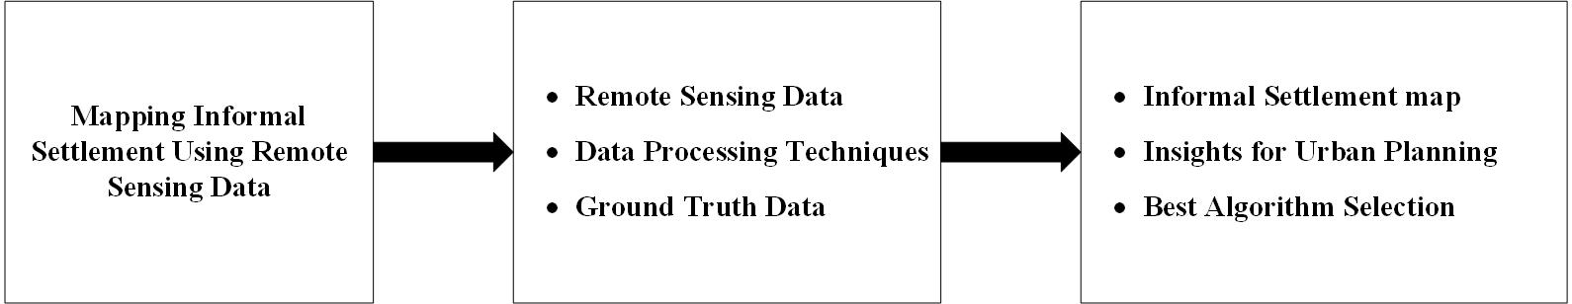

***Figure 2.1 Conceptual framework of the study (Source: Authors’ construct, 2023)***

# CHAPTER THEE

# METHODOLOGY

## 3.1 Introduction

Rapid urbanization in developing nations often leads to the rise of informal settlements, with substandard housing and inadequate access to basic amenities. Understanding their spatial distribution is essential for urban planning and policy-making aimed at improving the quality of life in these areas. This methodology report details an approach for mapping and classifying informal settlements in Greater Kumasi, a major urban hub in Ghana's Ashanti Region, using Sentinel-2 satellite imagery. The study incorporates pixel-based and object-based image analyses, cloud-masking techniques, and machine learning algorithms to accurately identify and delineate these settlements. The robust methodology outlined here can serve as a valuable guide for researchers and policymakers seeking to leverage remote sensing technologies for urban planning and management.

## 3.2 Study Area Selection

The research focuses on Greater Kumasi of Ashanti Region, which is one of Ghana’s biggest cities. Greater Kumasi is an urban agglomeration and a metropolitan area located in the Ashanti Region of Ghana, West Africa. It encompasses Kumasi, the second-largest city in Ghana, and its surrounding districts. Greater Kumasi serves as a major economic, cultural, and political hub for the region. The area is known for its rich historical and cultural heritage, with Kumasi being the traditional seat of the Ashanti kingdom. The Ashanti people, known for their vibrant traditions and craftsmanship, have a strong presence in Greater Kumasi, contributing to the city's unique cultural identity. Kumasi is near Lake Bosomtwe, in a rain forest region, and is the commercial, cultural and industrial capital of the historical Ashanti Empire. Kumasi is approximately 500 kilometers north on the Equator and 200 kilometers north of the Gulf of Guinea. Greater Kumasi is an extension of Kumasi Metropolitan Assembly to include newly created assemblies. Kumasi being the second-largest city in Ghana, presents a compelling study area for mapping informal settlements due to several factors. One of the key reasons is the prevalence of informal settlements within the city. Like many rapidly growing urban centers in developing countries, Kumasi faces significant challenges related to urbanization and population growth, leading to the emergence of informal settlements.

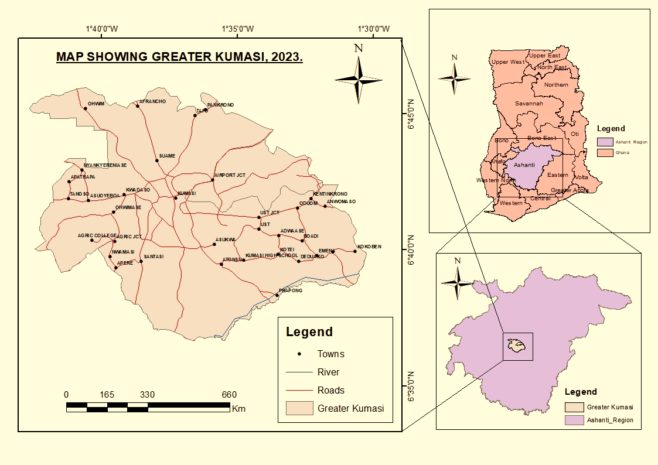

Figure 3.1 Map of Greater Kumasi (Source: Authors’ Construct)

These settlements, characterized by inadequate housing and limited access to basic services, offer a valuable opportunity to study their spatial distribution, growth patterns, and socio-economic conditions. In addition to the prevalence of informal settlements, Kumasi likely has a wealth of geospatial data available for analysis. Being an important city for urban planning and development, it is probable that high-quality and up-to-date satellite imagery, such as Sentinel-2 data, can be accessed. Such imagery is crucial for detailed land cover mapping, making it suitable for identifying and delineating informal settlements. Moreover, with the increasing use of geospatial technologies and open data initiatives, relevant datasets, including census data, socio-economic indicators, and administrative boundaries, are more likely to be accessible. These datasets can provide valuable context and insights into the characteristics and dynamics of informal settlements in Kumasi. The research relevance of mapping informal settlements in Kumasi cannot be understated. The findings of such a study hold significance for a variety of stakeholders, including urban planners, policymakers, and development organizations. Understanding the spatial patterns of urban poverty, housing inadequacy, and social disparities can inform the design of effective policies and interventions to address the needs and challenges faced by these marginalized communities.

## 3.3 Data Collection and Analysis Workflow

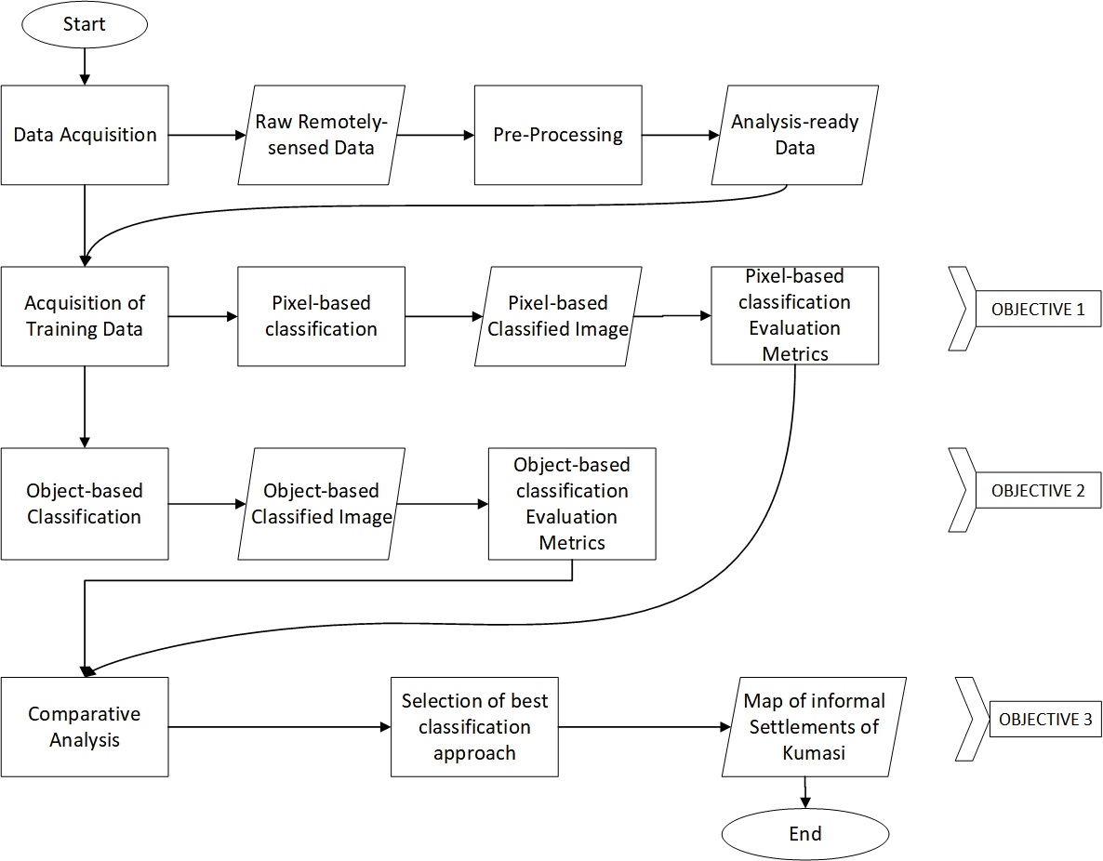

Figure 3.2 flow chart of the study (Source: Author’s Construct,2023)

## 3.4 Data Acquisition

To map informal settlements using Sentinel-2 data on Google Earth Engine, we will utilize the satellite imagery obtained from the Sentinel-2 mission, which is a part of the Copernicus program operated by ESA. Sentinel-2 satellites capture multispectral imagery in 13 bands, offering high-resolution (10m by 10m) and comprehensive spectral information, making it suitable for mapping informal settlements. The data is freely accessible through the Copernicus Open Access Hub and Google Earth Engine's data catalog, providing global coverage with a temporal archive extending over several years. The spatial resolution of 10m by 10m is crucial for distinguishing small features present in informal settlements, while the spectral resolution enables the identification of different construction materials and land cover characteristics. To account for seasonal variations and mitigate cloud cover effects, we will acquire a time series of Sentinel-2 images covering multiple dates over several months. These imageries will be used for cloud-masking. Cloud masking is a crucial step in processing satellite imagery, specifically Sentinel-2 data, for mapping informal settlements. It involves identifying and removing cloud-covered pixels to retain only clear and usable areas for analysis. Cloud detection techniques include thresholding, spectral indices, and machine learning-based approaches. By applying the cloud mask, we can ensure that the resulting imagery is free from cloud interference, leading to more accurate and reliable mapping results. For obtaining training and validation samples, Google Earth Pro serves as a valuable resource. By zooming in and panning around the study area, informal settlements and their surroundings can be identified. Marked locations representing informal settlements and formal settlement areas are saved as a KML/KMZ file. These labeled samples are then uploaded into Google Earth Engine, where they are utilized to train and validate classification algorithms, ensuring accurate and reliable mapping of informal settlements. By leveraging the capabilities of Google Earth Engine and the data from Sentinel-2, we can effectively map and monitor informal settlements with high precision and spatial resolution.

## 3.5 Data Preprocessing

The first step involved acquiring Sentinel-2 satellite imagery with 10m-by-10m resolution, covering the study area of interest, using the Earth Engine API. The acquired images were then calibrated to correct for radiometric and geometric distortions, ensuring accurate representation of true reflectance values and proper geo-referencing. Subsequently, cloud masking techniques were applied using Earth Engine's cloud masking algorithms to identify and remove cloud-covered regions, which could interfere with the classification process. Earth Engine provides a range of cloud masking methods that automatically detect and mask cloud-contaminated pixels from the Sentinel-2 imagery. To focus on the specific region of interest where informal settlements were expected to be present, the satellite imagery was subsetted using Earth Engine's spatial filtering capabilities. Additionally, if multiple image tiles were available, they were mosaicked together using Earth Engine's image compositing functions to create a seamless and continuous image covering the entire study area. Radiometric enhancement techniques such as histogram equalization or contrast stretching were applied within Earth Engine's processing environment to improve the visual interpretation and classification accuracy of the imagery. Moreover, Earth Engine automatically handles data resampling and image registration tasks, ensuring that all the satellite images used in the analysis had the same spatial resolution and coordinate system.

## 3.6 Feature Extraction

Using Sentinel-2 data to map informal settlements, feature extraction is a vital step. Both object-based and pixel-based feature extraction methods were utilized to capture relevant information. Spectral information, texture, shape, size, vegetation density, urban infrastructure, and, most significantly, the gaps between individual buildings were all taken into account as key indicators. Spectral bands provided unique signatures in informal settlements, reflecting the state of their construction materials (roofing sheet). Texture analysis helped differentiate settlements from surrounding areas due to irregular construction patterns. The irregular shapes and smaller sizes of informal settlements helped distinguish them from formal urban areas. Limited vegetation cover around settlements and the presence of roads, paths and spaces between individual buildings are indicative features. Object-based image analysis (OBIA) is used for automated feature extraction and segmentation, capturing contextual information, including the spaces between individual buildings. On the other hand, pixel-based classification utilizes the spectral information from individual pixels, enabling the inclusion of pixel-level features in the analysis. The Random Forest machine learning algorithm is then employed to classify pixels or segments as informal settlement or non-settlement areas. By incorporating the spaces between buildings as a factor in both approaches, the mapping accuracy is improved, leading to a comprehensive understanding of informal settlements from Sentinel-2 imagery. This combined approach efficiently identifies complex patterns and irregularly shaped features commonly found in informal settlements, producing more accurate and reliable results.

## 3.7 Classification or Segmentation Techniques

Object-Based Image Analysis (OBIA) was employed as a powerful technique to map informal settlements from remote sensing data. In this process, the satellite imagery was first segmented into meaningful objects or regions using the SNIC (Simple Non-Iterative Clustering) algorithm. SNIC performed super pixel-based clustering, grouping pixels with similar spectral and spatial characteristics into compact and homogeneous regions, creating super pixels. These super pixels served as the building blocks for further analysis. Next, features were extracted from each super pixel, including spectral information, texture, shape, size, and other relevant attributes that described the characteristics of each region. These features were used to create meaningful objects in the image, representing individual buildings, groups of buildings, or other relevant features within the context of informal settlements. The hierarchical analysis enabled a multi-scale representation of the objects, capturing both small and large settlements. The classification stage involved using a supervised classification algorithm (Random Forest), to classify the objects into different land cover classes, including informal settlements, formal settlements, vegetation, water and bare land. The Random Forest algorithm leveraged the features extracted from the objects to learn the spectral signatures and contextual relationships of various land cover types. After the classification, post-processing steps were applied to refine the results and remove any noise or misclassifications. The accuracy of the classification results was assessed through validation using separate validation data, ensuring the reliability of the mapping output.

## 3.8 Validation and Accuracy Assessment

The accuracy assessment of the informal settlement mapping results involved validating and comparing the classified or segmented areas with the validation data. The dataset collected from Google earth image was split into two with one third as the validation set. These validations set served as the truth data providing the reference for evaluating the accuracy of the mapping outputs. Statistical metrics and indices were used to quantify the accuracy of the informal settlement mapping results. The overall accuracy was calculated as the percentage of correctly classified or segmented pixels or objects compared to the total number of pixels or objects in the validation dataset, giving a general measure of the model's correctness. The producer's accuracy, also known as recall or sensitivity, represented the percentage of validation set informal settlement locations correctly identified by the mapping model, assessing its ability to detect informal settlements. The user's accuracy, also known as precision, indicated the percentage of correctly classified or segmented pixels or objects for the informal settlement class compared to the total number of pixels or objects classified as informal settlements, measuring the model's accuracy in labeling informal settlements. Moreover, the Kappa coefficient was computed to measure the agreement between the predicted classifications and the ground truth data, accounting for the agreement that could occur by chance alone. A Kappa coefficient of 1 indicates perfect agreement, while values closer to 0 suggested agreement no better than chance, providing a more robust evaluation of the mapping results' reliability. These accuracy assessment measures were crucial in determining the effectiveness and reliability of the mapping approach for informal settlement identification based on the past activities of field surveys and mapping procedures.

# CHAPTER FOUR

# RESULTS AND DISCUSSION

## 4.1 Introduction

This chapter presents the findings obtained from the application of remote sensing for the mapping of informal settlements. The outcomes are discussed in the context of the study's objectives and previous research in this field. The chapter also explores the implications of these findings for policy-making, urban planning, and future research.

## 4.2 Pixel-based Image Analysis

Based on the analysis (refer to figure 4.1), the study discovered that informal settlements tend to cluster or concentrate predominantly in Greater Kumasi.

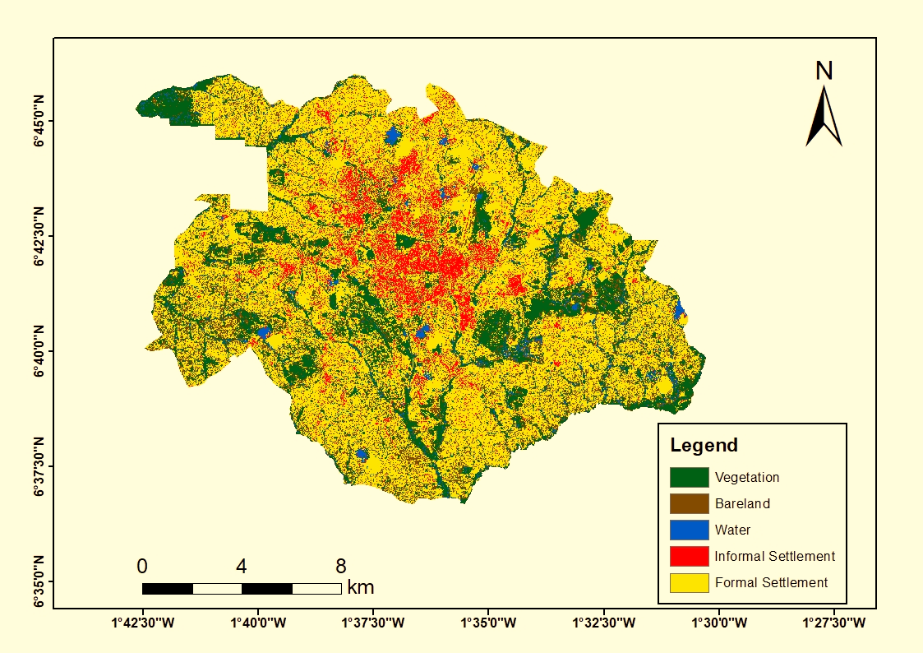

Figure.4.1 Pixel-based Analytical map of Greater Kumasi

. The data also shows a partial distribution of informal settlements across the entirety of Greater Kumasi. This scattered presence is less concentrated, but it nonetheless paints a picture of a significant population dwelling outside the central cluster. Moreover, using Pixel-based Image Analysis (refer to Figure 4.2), the study examined the division of informal and formal settlements in the Greater Kumasi region. The study findings present a unique perspective on the urban layout and land use of the region.

Figure.4.2 Comparative Analysis of Informal and formal settlement from the pixel-base Map

The results indicate that informal settlements account for approximately 14% of the total settlements within the Greater Kumasi area. This is a significant portion and demonstrates the considerable presence of informal dwelling areas within the region. In contrast, formal settlements constitute the vast majority of dwellings, occupying around 86% of the total area. This dominance of formal settlements represents a major part of the urban fabric in Greater Kumasi and shows the extent of planned and regulated urban development in the region.

## 4.3 Object-based Image Analysis

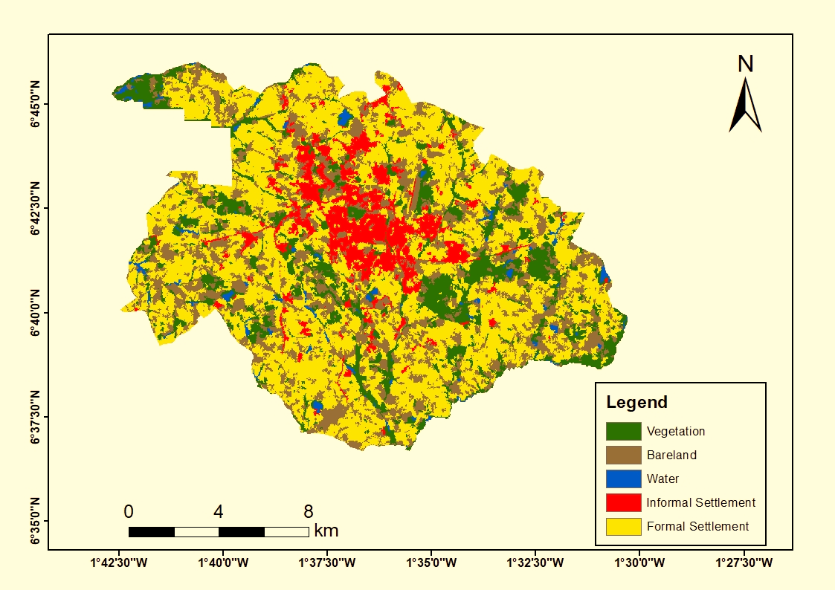From the Object-based Image Analysis (See Figure 4.3), we observe that the informal settlements, although still predominantly concentrated in the center of Greater Kumasi, appear to be divided into more fractured segments. This fragmentation suggests a varied and complex pattern of informal development, possibly indicating growth in response to specific localized conditions and opportunities.

Figure.4.3 Object-based Analytical map of Greater Kumasi

Also, when compared to the Pixel-based Image Analysis (see Figure 4.1), the informal settlements appear notably denser in the Object-based map. This increased thickness could reflect a higher density of dwellings or could be a result of the different ways that the Object-based Image Analysis represents physical space. These disparities between the two maps emphasize the importance of leveraging multiple analysis methods to gain a comprehensive understanding of urban dynamics. It also underscores that, while the informal settlements are predominantly centralized, their morphology is complex and fragmented.

Figure.4.4 Comparative Analysis of Informal and formal settlement from the Object-based Map

## 4.3 Test of Accuracy for Pixel-based Image Analysis and Object-based Map

The following are confusion matrices for the validation test of both pixel-based classification and object-based classification.

Table 3.1 confusion matrix for the pixel-based classification

|  |  |  |  |  |  |
| --- | --- | --- | --- | --- | --- |
|  | Vegetation | Bare land | Water | Informal Settlement | Formal Settlement |
| Vegetation | 6973 | 151 | 50 | 16 | 52 |
| Bare land | 59 | 473 | 150 | 61 | 109 |
| Water | 157 | 25 | 37 | 90 | 37 |
| Informal Settlement | 108 | 77 | 139 | 842 | 171 |
| Formal Settlement | 140 | 40 | 140 | 148 | 1755 |

Table 3.2 confusion matrix for the object-based classification

|  |  |  |  |  |  |
| --- | --- | --- | --- | --- | --- |
|  | Vegetation | Bare land | Water | Informal Settlement | Formal Settlement |
| Vegetation | 6740 | 123 | 35 | 67 | 134 |
| Bare land | 27 | 324 | 165 | 61 | 53 |
| Water | 75 | 9 | 11 | 149 | 40 |
| Informal Settlement | 39 | 83 | 6 | 811 | 58 |
| Formal Settlement | 115 | 58 | 13 | 19 | 1860 |

### 4.3.1 Accuracy computations

4.3.1.1 Overall Accuracy and Kappa value

The overall accuracy is the sum of the correct predictions (the main diagonal of the confusion matrix) divided by the total number of predictions.

Pixel-based Accuracy =

= 0.84

Pixel-based Kappa Accuracy = 0.725

Object-based Accuracy =  
 = 0.88

Object-based Kappa Accuracy = 0.781

calculating the Precision, Recall, and F1-score, focusing on the class corresponding to informal settlements.

4.3.1.2 Pixel based Accuracy computations for informal settlements

For the informal settlements class (fourth row and column):

True Positives (TP): 842 (Instances correctly identified as informal settlements)

False Positives (FP): 16+61+90+148 = 315 (Other instances incorrectly identified as informal settlements)

False Negatives (FN): 108 + 77 + 139 + 171 = 495 (Informal settlements incorrectly identified as other)

True Negatives (TN): Everything else = Sum of all values - TP - FP - FN = 10348

With these, we calculate:

Accuracy = (TP + TN) / (TP + FP + FN + TN) = (1755 + 8422) / (1755 + 468 + 1166 + 8422) = 0.933

Precision = TP / (TP + FP) = 842 / (842 + 315) = 0.728

Recall = TP / (TP + FN) = 842 / (842 + 495) = 0.630

F1 Score = 2 * (Precision * Recall) / (Precision + Recall) = 2 * (0.728 * 0.630) / (0.728+ 0.630) = 0.675

4.3.1.3 Object-based computations for informal settlements

True Positives (TP): 811

False Positives (FP): 67+61+149+13 = 290

False Negatives (FN): 39 + 83 + 6 + 58 = 186

True Negatives (TN): Everything else = Sum of all values - TP - FP - FN = 9788

So,

Accuracy = (TP + TN) / (TP + FP + FN + TN) = (811 + 9788) / (811 + 290 + 186 + 9788) = 0.957

Precision = TP / (TP + FP) = 811 / (811 + 290) = 0.737

Recall = TP / (TP + FN) = 811 / (811 + 186) = 0.813

F1 Score = 2 * (Precision * Recall) / (Precision + Recall) = 2 * (0.737* 0.813) / (0.737 + 0.813) = 0.773

4.3.1.4 Accuracy

In terms of accuracy, which is defined as the proportion of correct predictions (both true positives and true negatives) among the total number of cases examined, both models demonstrated high performance. The pixel-based approach achieved an accuracy of 0.9325 while the object-based approach achieved an accuracy of 0.957. These high values indicate that both models were effective in their classifications the majority of the time.

4.3.1.5 Precision

Precision, or the ratio of true positives to the sum of true positives and false positives, measures the correctness achieved in the positive predictions. The precision values obtained were 0.728 for the pixel-based approach and 0.737 for the object-based approach. Slightly higher precision for the object-based model implies a lower rate of false-positive errors, indicating fewer instances of non-informal settlements being incorrectly identified as informal.

4.3.1.6 Recall

Recall (also known as sensitivity), on the other hand, represents the ability of the classifier to find all the positive instances. It is calculated as the ratio of true positives to the sum of true positives and false negatives. The object-based approach demonstrated a significant advantage in this regard with a recall of 0.813, compared to the pixel-based approach with a recall of 0.630. This suggests that the object-based model was more effective at correctly identifying informal settlements.

4.3.1.7 F1 Score

The F1 Score, which is the harmonic mean of precision and recall, serves as a measure of a test's accuracy and robustness. In our case, the F1 Score of the object-based approach was 0.773, outperforming the pixel-based approach, which scored 0.675.

## 4.4 Discussion of findings

The primary objective of this research was to map informal settlements in Greater Kumasi utilizing low resolution satellite image (Sentinel-2 imagery). For classification, two image analysis methods were employed: pixel-based and object-based.

In pixel-based image analysis, the unit of analysis is each individual pixel. The method demonstrated a satisfactory performance, achieving an overall accuracy of 93.25%, precision of 72.77%, recall of 62.98%, and an F1 score of 67.52%. Despite a respectable accuracy, the recall score reveals a potential area for improvement. This limitation becomes particularly evident in regions characterized by mixed land use or complex urban structures. Here, pixels representing informal settlements can share spectral characteristics with other land cover types, which results in overestimation. A notable example of this is the spectral similarity between informal settlements and adjacent industrial zones, often due to shared materials such as metal roofs. In contrast, object-based image analysis, which views groups of pixels or image objects as a unit, exhibited superior performance across all metrics. It achieved an overall accuracy of 95.70%, precision of 73.66%, recall of 81.34%, and an F1 score of 77.31%. Nevertheless, even this method was not without its own anomalies. During the segmentation process, small clusters of informal settlements were sometimes incorrectly merged with adjacent non-settlement regions, leading to an underestimation of settlement extent. This was due primarily to the inherent variability in the size and shape of informal settlements, as well as instances where image objects did not align with actual ground features. Comparing the two methods, object-based image analysis outperformed its pixel-based counterpart in every metric. This superiority is expected since the object-based method incorporates spatial, spectral, and contextual information about groups of pixels, enabling it to yield robust results even in complex urban environments. In contrast, pixel-based methods, despite their lower accuracy, may be preferred for quick overviews due to their simpler computational requirements.

# CHAPTER FIVE

# CONCLUSION AND RECOMMENDATION

## 5.1 Conclusion

This study rigorously evaluated two predominant image analysis techniques, pixel-based and object-based, for the specific task of delineating and classifying informal settlements employing Sentinel-2 imagery. The findings from our investigation underscore the successful applicability of both techniques, each exhibiting distinct advantages and limitations. The pixel-based image analysis, while displaying appreciable accuracy, encounters challenges in regions characterized by intricate urban configurations and heterogeneous land use, potentially leading to misclassification. This is primarily attributed to the technique's fundamental basis of treating each pixel as an independent analytical unit, thereby ignoring the context and spatial associations with its neighboring pixels. As such, pixels depicting informal settlements could inadvertently display spectral properties similar to other disparate land cover categories. Conversely, the object-based image analysis technique, which conceptualizes a set of pixels as an interconnected unit, has manifested a superior performance profile in terms of accuracy, precision, recall, and the F1 score. However, it is not without its shortcomings, particularly with the tendency to amalgamate smaller clusters of informal settlements with adjoining non-settlement zones during the segmentation phase. On a comparative note, the object-based image analysis technique outshines its pixel-based counterpart, positioning it as a more dependable technique for identifying and classifying informal settlements from Sentinel-2 imagery. Nonetheless, the selection of the optimal technique should be an informed decision considering several crucial aspects such as the computational resources at disposal, project timeline, and the specific requirements of the project.

## 5.2 Recommendations

Based on the findings of our research, we recommend the following:

1. For projects requiring high precision and detailed analyses of informal settlements, object-based image analysis should be the method of choice, given its robust performance and ability to handle complex urban environments.
2. However, if the research project's focus is to provide a quick overview or if computational resources are limited, pixel-based image analysis, despite its lower accuracy, may be a more suitable choice.
3. Future research should continue to improve the segmentation process in object-based image analysis to better align image objects with actual ground features. This could mitigate issues such as the underestimation of settlement extent.
4. The development of hybrid methods that combine the strengths of both pixel-based and object-based image classification could be a fruitful avenue for future research. This could offer more nuanced and accurate representations of informal settlements.
5. It is also recommended to use additional data sources, like higher-resolution images or ground truth data, to improve the accuracy of classifications, particularly in complex urban environments.

# REFERENCE

1. Abass, A.S. and Kucukmehmetoglu, M. (2021) "Transforming slums in Ghana: The urban regeneration approach." ''Cities'', 116, p.103284.
2. Abo-Zahhad, M., Al-Shami, T. M., Al-Faraj, F. A., and Al-Mashharawi, S. 2019. "Spatial Analysis of Informal Settlements Using Remote Sensing and GIS: A Case Study from Riyadh City, Saudi Arabia." ISPRS International Journal of Geo-Information, 8(3), 132.
3. Acolin, A. and Kim, A.S. (2021) “Algorithmic justice and groundtruthing the remote mapping of informal settlements: The example of Ho Chi Minh City’s periphery,” Environment and Planning B: Urban Analytics and City Science, 49(1), pp. 151–168.
4. Adarkwa, K.K. and Post, J. (eds.) (2001). The fate of the tree: planning and managing the development of Kumasi, Accra. Woeli Publishing Services.
5. Amis, P., Preston, A. and Turner, W. (2016) Urban governance Topic guide About GSDRC. Available at: www.nationalarchives.gov.uk/doc/open-government-licence.
6. Amoako, C & Cobbinah, P 2011, 'SLUM IMPROVEMENT IN THE KUMASI METROPOLIS, GHANA: A REVIEW OF APPROACHES AND RESULTS', Journal of Sustainable Development in Africa, vol. 13, no. 8, pp. 150-170
7. Ansari, R.A., Malhotra, R. and Buddhiraju, K.M. (2020) “Identifying informal settlements using Contourlet assisted deep learning,” Sensors, 20(9), p. 2733.
8. Assarkhaniki, Z., Sabri, S. and Rajabifard, A., 2021. Using open data to detect the structure and pattern of informal settlements: an outset to support inclusive SDGs’ achievement. Big Earth Data, 5(4), pp.497-526.
9. Bempah, S. et al. (2021) “Fine Scale Replicable risk mapping in an informal settlement: A Case study of Mathare, Nairobi,” Journal of Health Care for the Poor and Underserved, 32(1), pp. 354–372.
10. Bhagat, R. B., Omranian, E., & Bregt, A. K. (2019). ‘An approach to map and monitor informal settlements using volunteered geographic information.’ Remote Sensing, 11(5), 499.
11. Bhagat, R. B., Sinha, A. K., Roy, P. S., and Chakraborty, S. (2019). "Mapping Slums in Delhi, India, Using Google Earth and Remote Sensing Data." Applied Geography, 101, 10-22.
12. Bhagat, R.B. & Rutten, M.M. 2016, 'Participatory mapping for informal settlement upgrading in India: A review', Landscape and Urban Planning, 153, pp. 133-148.
13. Capalbo, F. L., Atzberger, C., Matricardi, E., & Moreno, J. (2020). ‘Mapping Informal Settlements in Developing Countries with Open-Access Satellite Data.’ Remote Sensing, 12(3), 401.
14. Capalbo, S. M., Engstrom, R. N., and Li, W. (2020). "Mapping Urban Informal Settlements in Developing Countries using Machine Learning and Google Earth Engine." International Journal of Remote Sensing, 41(16), 6263-6286.
15. Capdevila, I., Pérez-Foguet, A. & Saurí, D. 2016, 'Can Drones Help Urban Studies? Planning and Participatory Mapping in Informal Settlements', Cartographic Journal, 53(4), pp. 402-411.
16. Casado, M.R. et al. (2016) ‘Quantifying the effect of aerial imagery resolution in automated hydromorphological river characterisation’, Remote Sensing, 8(8). Available at: https://doi.org/10.3390/rs8080650.
17. Chi, M. et al. (2016) ‘Big Data for Remote Sensing: Challenges and Opportunities’, Proceedings of the IEEE, 104(11), pp. 2207–2219. Available at: https://doi.org/10.1109/JPROC.2016.2598228.
18. Congalton, R.G. (2015) ‘Remote Sensing and Image Interpretation. 7th Edition’, Photogrammetric Engineering & Remote Sensing, 81(8). Available at: https://doi.org/10.14358/pers.81.8.615.
19. Counihan, C.H., 2017. An incremental intervention in Jakarta: An empowering infrastructural approach for upgrading informal settlements.
20. Doshi, S. & Garg, R.D. 2018, 'Mapping of informal settlements using satellite and UAV imagery: A review', International Archives of the Photogrammetry, Remote Sensing and Spatial Information Sciences, 42(4), pp. 215-220.
21. Dovey, K. and King, R. (2011) ‘Forms of informality: Morphology and visibility of informal settlements’, Built Environment, 37(1), pp. 11–29. Available at: https://doi.org/10.2148/BENV.37.1.11.
22. Du, S., Zhang, F. and Zhang, X. (2015) “Semantic classification of urban buildings combining VHR image and GIS data: An improved random forest approach,” ISPRS Journal of Photogrammetry and Remote Sensing, 105, pp. 107–119.
23. Fallatah, A., Jones, S. and Mitchell, D., 2020. Object-based random forest classification for informal settlements identification in the Middle East: Jeddah a case study. International Journal of Remote Sensing, 41(11), pp.4421-4445.
24. Fallatah, A., Jones, S., Mitchell, D. and Kohli, D., 2018. Mapping informal settlement indicators using object-oriented analysis in the Middle East. International journal of digital earth, 12(7), pp.802-824.
25. Fan, R. et al. (2022) “Urban informal settlements classification via a transformer-based spatial-temporal fusion network using multimodal remote sensing and time-series human activity data,” International Journal of Applied Earth Observation and Geoinformation, 111, p. 102831.
26. Feng, L., Liu, Y., Tian, Y., and Liu, Y. (2019). "A Dynamic Mapping Approach for Informal Settlements using Multi-temporal Remote Sensing Images." International Journal of Applied Earth Observation and Geoinformation, 78, 285-297.
27. Feng, Y., Liu, Y., Xu, X., & Yu, B. (2019). ‘Object-based building change detection in informal settlements from VHR images.’ Remote Sensing, 11(5), 551.
28. Foody, G. M. 2002. "Status of Land Cover Classification Accuracy Assessment." Remote Sensing of Environment, 80(1), 185-201.
29. Goodchild, M. F., and Janelle, D. G. (Eds.). 2010. Spatially Integrated Social Science. Oxford University Press.
30. Gram-Hansen, B.J., Helber, P., Varatharajan, I., Azam, F., Coca-Castro, A., Kopackova, V. and Bilinski, P., 2019, January. Mapping informal settlements in developing countries using machine learning and low resolution multi-spectral data. In Proceedings of the 2019 AAAI/ACM Conference on AI, Ethics, and Society (pp. 361-368).
31. Gram-Hansen, S., Patel, D., Sreekrishnan, A., and Guarnieri, A. (2019). "Mapping Informal Settlements with High-Resolution Satellite Imagery, Population Data, and Convolutional Neural Networks." ISPRS Journal of Photogrammetry and Remote Sensing, 157, 174-186.
32. Habitat, U. (2013) State of the World’s Cities 2012/2013: Prosperity of Cities.
33. Hagen, E., 2017. Open mapping from the ground up: learning from Map Kibera.
34. Helber, P., Bauder, A., d'Angelo, P., and Siegmann, B. (2018). "Mapping Informal Settlements in Nairobi, Kenya, Using Machine Learning on Satellite Imagery." Remote Sensing, 10(6), 847.
35. Hofmann, P., Strobl, J., Blaschke, T. and Kux, H., 2008. Detecting informal settlements from QuickBird data in Rio de Janeiro using an object-based approach. Object-based image analysis: Spatial concepts for knowledge-driven remote sensing applications, pp.531-553.
36. Hofmann, P., Taubenböck, H. and Werthmann, C. (2015) ‘Monitoring and modelling of informal settlements - A review on recent developments and challenges’, 2015 Joint Urban Remote Sensing Event (JURSE), pp. 1–4.
37. Hu, X., Lu, C., and Mukherjee, A. 2020. "Understanding Slums Using Remote Sensing and Machine Learning." Remote Sensing, 12(18), 3005.
38. Jensen, J. R. 2007. Remote Sensing of the Environment: An Earth Resource Perspective. Pearson Education, Inc.
39. Kerle, N. & Gerke, M. 2015, 'Urban remote sensing for urban planning: Drones and satellites', Urban Remote Sensing, CRC Press, pp. 175-202.
40. Khan, A. A., and Couclelis, H. 2002. "Simulating Sprawl." Environment and Planning B: Planning and Design, 29(4), 661-681.
41. Korah, P. et al. (2017) ‘Spatial plans and urban development trajectory in Kumasi, Ghana’, GeoJournal, 82. Available at: https://doi.org/10.1007/s10708-016-9731-1.
42. Kuffer, M., Pfeffer, K. and Sliuzas, R. (2016) ‘Slums from space-15 years of slum mapping using remote sensing’, Remote Sensing. MDPI AG. Available at: https://doi.org/10.3390/rs8060455.
43. Kuffer, M., Pfeffer, K., Sliuzas, R., & Baud, I. (2021). ‘Ten years of urban remote sensing applied to human settlement mapping: A systematic review.’ ISPRS Journal of Photogrammetry and Remote Sensing, 177, 196-221.
44. Kuffer, M., Pfeffer, K., and Sliuzas, R. (2021). "Automated Detection of Informal Settlements from VHR Imagery using Deep Learning." Remote Sensing, 13(7), 1268.
45. Kuffer, M., Vanhuysse, S., Georganos, S., & Wang, J. (2021). Meeting User Requirements for Mapping and Characterizing Deprived Urban Areas in Support of Pro-Poor Policies. GI_Forum, 1, 85–93. https://doi.org/10.1553/giscience2021_01_s85
46. Lillesand, T., Kiefer, R. and Chipman, J. (2014) Remote sensing and image interpretation, Australian Journal of Geodesy, Photogrammetry & Surveying. Edited by Wiley. Available at: https://www.wiley.com/en-us/Remote+Sensing+and+Image+Interpretation%2C+7th+Edition-p-9781118343289.
47. Makena, H., Shalaby, A., El Mahdy, S., & Tateishi, R. (2022). ‘Assessing the impact of informality in informal settlements on urban expansion using remote sensing.’ Urban Remote Sensing, 5, 100066.
48. Makena, J., Zhang, X., and Alzahrani, B. (2022). "Urban Informal Settlements Detection and Mapping Using Deep Learning Techniques: A Case Study of Nairobi, Kenya." Journal of Remote Sensing & GIS, 11(2), 100045.
49. Marshall, I., Cui, X., Guo, S., and Dong, S. 2017. "The Use of Remote Sensing and GIS in Humanitarian Crises: A Case Study from South Sudan." International Journal of Digital Earth, 10(1), 103-123.
50. Matarira, D., Mutanga, O. and Naidu, M. (2022) ‘Google Earth Engine for Informal Settlement Mapping: A Random Forest Classification Using Spectral and Textural Information’, Remote Sensing, 14(20). Available at: https://doi.org/10.3390/rs14205130.
51. Matarira, D., Mutanga, O. and Naidu, M. (2022) “Texture analysis approaches in modelling informal settlements: a review,” Geocarto International, 37(26), pp. 13451–13478.
52. Mwanundu, S. and Fara, K. (2009) Enabling poor rural people to overcome poverty Good practices in participatory mapping A review prepared for the International Fund for Agricultural Development (IFAD). Available at: www.ifad.orgwww.ruralpovertyportal.org.
53. Netzband, M. and Rahman, A. (2009) "Physical characterisation of deprivation in cities: How can remote sensing help to profile poverty (slum dwellers) in the megacity of Delhi/India?" In: Proceedings of the IEEE Joint Urban Remote Sensing Event. Shanghai, China, 20-22 May 2009, pp. 1-5.
54. Ozesmi, S. L., and Bauer, M. E. 2002. "Satellite Remote Sensing in Ecology: Methods and Applications." Ecological Applications, 12(3), 850-867.
55. Pesaresi, M., Freire, S., Julea, A., Florczyk, A., and Corbane, C. (2020). "The Status of Global Human Settlement Layer 2019." Remote Sensing, 12(11), 1858.
56. Pesaresi, M., Huadong, G., Blaes, X., Ehrlich, D., Ferri, S., Gueguen, L., ... & Florczyk, A. J. (2020). “A global human settlement layer from optical HR/VHR RS data: Concept and first results.” IEEE Journal of Selected Topics in Applied Earth Observations and Remote Sensing, 6(5), 2102-2131.
57. Pinto, F. et al. (2023) ‘Satellite imagery for high-throughput phenotyping in breeding plots’, Frontiers in Plant Science, 14. Available at: https://doi.org/10.3389/fpls.2023.1114670.
58. Proietti, C., & Siragusa, A. (2023). ‘Mapping Urban Informal Settlements Through Remote Sensing and GIS: A Review of Methods and Applications.’ Remote Sensing, 15(2), 285.
59. Puissant, A., Weber, C., and Dufourmont, J. 2018. "Urban Sprawl Detection from Remote Sensing Data: A Review." Remote Sensing, 10(9), 1447.
60. Rambaldi, G., Chambers, R., and Wandera, C. 2006. "Mapping for Results - Using Remote Sensing Technology to Strengthen Local Voices." IIED, London.
61. Ramirez-Lovering, D., Spasojevic, D. and Prescott, M.F. (2020) “Mapping informal settlements,” in Routledge eBooks, pp. 138–148.
62. Rumbach, A. and Kim, A. (2016) ‘Predictors of household exposure to monsoon rain hazards in informal settlements.’ Natural Hazards, 85(2), pp. 709–728.
63. Santos, M. J., Veloso, A., Almeida, J. P., and Goncalves, J. A. (2018). "Mapping Urban Informal Settlements with Very High-Resolution Satellite Imagery: A Fully Automated Method based on Spectral, Textural, and Contextual Information." Remote Sensing, 10(3), 351.
64. Santos, M. Y. R., Martins, V. M. A., & Pereira, G. A. S. (2018). ‘Informal settlement detection in complex urban environments from multitemporal analysis of very high-resolution optical images.’ Remote Sensing, 10(12), 2017.
65. Singh, A. & Ghosh, K.G. 2019, 'Role of remote sensing and GIS in urban planning: A review', Smart Cities and Technology, Springer, Singapore, pp. 221-236.
66. Sirmacek, B. & Unsalan, C. 2018, 'Automatic building detection from aerial imagery using deep learning', Remote Sensing,10(5), p. 699.
67. Stark, T., Wurm, M., Taubenböck, H. and Zhu, X.X., 2019, May. Slum mapping in imbalanced remote sensing datasets using transfer learned deep features. In 2019 Joint Urban Remote Sensing Event (JURSE) (pp. 1-4). IEEE
68. Stumpf, A., Kerle, N., and Nex, F. 2018. "Object-Based Image Analysis for Remote Sensing." ISPRS Journal of Photogrammetry and Remote Sensing, 145, 93-106.
69. Sun, S. et al. (2022) ‘Remote Sensing Image Interpretation With Semantic Graph-Based Methods: A Survey’, IEEE Journal of Selected Topics in Applied Earth Observations and Remote Sensing, 15, pp. 4544–4558. Available at: https://doi.org/10.1109/JSTARS.2022.3176612.
70. Takyi, S.A., Amponsah, O., Yeboah, A.S. and Mantey, E., 2021. Locational analysis of slums and the effects of slum dweller’s activities on the social, economic and ecological facets of the city: insights from Kumasi in Ghana. GeoJournal, 86, pp.2467-2481.) restructure this for havard style in text citation
71. Tjia, D. and Coetzee, S. (2022) “Geospatial information needs for informal settlement upgrading – A review,” Habitat International, 122, p. 102531.
72. Toulmin, C., 2009. Securing land and property rights in sub-Saharan Africa: The role of local institutions. Land use policy, 26(1), pp.10-19.
73. UN-Habitat (2004) The challenge of slums: global report on human settlements 2003, Management of Environmental Quality: An International Journal, 15(3), pp. 337-338.
74. UN-Habitat (2015) ‘HABITAT III ISSUE PAPERS 22-INFORMAL SETTLEMENTS’. https://www.land.vic.gov.au/maps-and-spatial/imagery/aerial-imagery
75. Wang, C., Xu, H.-Y. and Lin, A. (2022) “Informal settlements in the context of COVID-19: Pandemic restrictions and the building of community resilience,” Indoor and Built Environment, p. 1420326X2210978.
76. Wang, L., Chen, X., Li, X., & Song, M. (2021). ‘Informal settlement detection in multitemporal images using weakly supervised learning.’ IEEE Transactions on Geoscience and Remote Sensing, 59(8), 6615-6626.
77. Wang, S., Miao, Z., Yan, L., Zhang, X., and Huang, L. (2021). "Mapping Informal Settlements in Urban Areas Using Very High-Resolution Satellite Images and Deep Learning." ISPRS International Journal of Geo-Information, 10(3), 150.
78. Weir, D., McQuillan, D. and Francis, R.A. (2019) ‘Civilian science: the potential of participatory environmental monitoring in areas affected by armed conflicts.’ Environmental Monitoring and Assessment, 191(10).
79. Williams, J., Quincey, D., and Stillwell, J. 2016. "Mapping Informal Settlements Using Remote Sensing Imagery: An Evaluation of Object-Based and Pixel-Based Approaches." Applied Geography, 73, 47-59.
80. Wurm, M., Taubenböck, H., Weigand, M. and Schmitt, A., 2017. ‘Slum mapping in polarimetric SAR data using spatial features.’ Remote sensing of environment, 194, pp.190-204.
81. Zhang, J., Shuang Chen, S., Gao, Q., Shen, Q., Kimirei, I.A. and Mapunda, D.W., 2020. Morphological characteristics of informal settlements and strategic suggestions for urban sustainable development in Tanzania: Dar es Salaam, Mwanza, and Kigoma. Sustainability, 12(9), p.3807.